Te Pihinga Stationery Requirements 2020
Years 3

Item | # Needed | Subject
3B1 Notebook | 2 | - Spelling  - Living Christianly verses
Warwick My Literacy Book 2 | 2 | - 2 x Draft Writing
1I5 | 2 | - spelling/word work
Warwick My Maths Book 1 | 2 | - Maths
Warwick My Everyday Book | 3 | - L.I.G.H.T.S.  - Living Christianly  - Spare
BRAND NEW RCS STUDENTS ONLY  Yellow 40 page Clearfile | 1 each | - Health/Circle Time  - Assessment

Please name all items.

A compulsory ‘Hub Stationery Fee’ of $27.00
is payable to the RCS office by Monday 10th February 2020.
This fee covers essential stationery used Hub wide.

Account: 02-1266-0035926-00 Ref: Surname and Invoice#

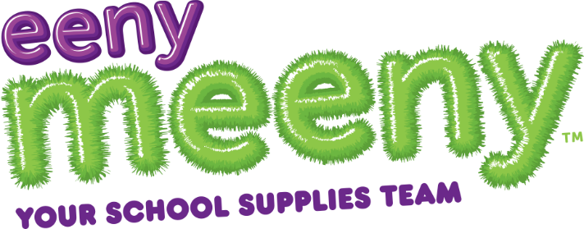 | All Stationery is on the Eeny Meeny website: www.schoolpacks.co.nz  If you have any issues please:  Email: schoolpacks@eenymeeny.co.nz  Phone: 0800 54 56 54

